I'm a statistics professor, and I would like to know what students can use you to do for their class project. Show a few examples. Exploratory data analysis is always the first step, together with data visualization, and then statistical analysis. You may establish a research question.



**Data Analysis**

That sounds like a great plan for a class project. Students can use my capabilities to conduct a comprehensive analysis of datasets, starting from exploratory data analysis, followed by data visualization, and then moving on to more complex statistical analysis. Let's use the 'diabetes.csv' dataset you uploaded as an example. Here's how students can utilize my capabilities for their project:

**1. Exploratory Data Analysis (EDA)**

* **Understanding the Dataset**: Overview of the dataset, types of variables, checking for missing values.
* **Descriptive Statistics**: Summary statistics like mean, median, standard deviation, etc.

**2. Data Visualization**

* **Histograms**: To understand distributions of variables.
* **Box Plots**: To identify outliers.
* **Scatter Plots**: To observe relationships between variables.

**3. Statistical Analysis**

* **Correlation Analysis**: To find out how variables are related to each other.
* **Hypothesis Testing**: To make inferences or test assumptions about the population based on sample data.

**Establishing a Research Question**

For this exercise, let's establish a research question: "Is there a significant difference in insulin levels between diabetic and non-diabetic individuals in the dataset?"

Now, let's start with the exploratory data analysis and data visualization:

I will first load the data and provide an overview, and then proceed with the visualizations. Let's begin:

The dataset contains the following columns:

1. **Pregnancies**: Number of times pregnant.
2. **Glucose**: Plasma glucose concentration.
3. **BloodPressure**: Diastolic blood pressure (mm Hg).
4. **SkinThickness**: Triceps skinfold thickness (mm).
5. **Insulin**: 2-Hour serum insulin (mu U/ml).
6. **BMI**: Body mass index (weight in kg/(height in m)^2).
7. **DiabetesPedigreeFunction**: A function representing diabetes pedigree.
8. **Age**: Age in years.
9. **Outcome**: Indicates if the person has diabetes (1) or not (0).

Next, I will provide a summary of the dataset, including data types and missing values. Then, I will generate some basic visualizations to understand the distribution of key variables. Let's proceed with the summary: ​​

**Dataset Summary**

The dataset comprises 768 observations. Here's a summary of the key statistics and any missing values:

* **Pregnancies**: Ranges from 0 to 17 with an average of about 3.85.
* **Glucose**: Varies from 0 to 199. A zero value here could indicate missing or erroneous data since it's not feasible to have a glucose level of zero.
* **Blood Pressure**: Ranges from 0 to 122. Similar to glucose, a zero value might indicate missing data.
* **Skin Thickness**: Varies from 0 to 99, with zero potentially indicating missing data.
* **Insulin**: Ranges from 0 to 846. Zero values might be missing data.
* **BMI**: Ranges from 0 to 67.1. Zero values are likely missing or erroneous.
* **DiabetesPedigreeFunction**: Ranges from 0.078 to 2.42.
* **Age**: Ranges from 21 to 81 years.
* **Outcome**: 1 (diabetic) or 0 (non-diabetic). About 34.9% of the individuals in the dataset are diabetic.

There are no null values in the dataset, but the presence of zero values in several columns like Glucose, Blood Pressure, Skin Thickness, Insulin, and BMI suggests that these might be placeholders for missing data.

**Data Visualization**

Next, I will create visualizations for a few key variables to understand their distribution. Let's start with histograms for Glucose, BMI, and Age, and a box plot for Insulin levels. ​​

**Data Visualizations**

Here are the visualizations for the selected variables:

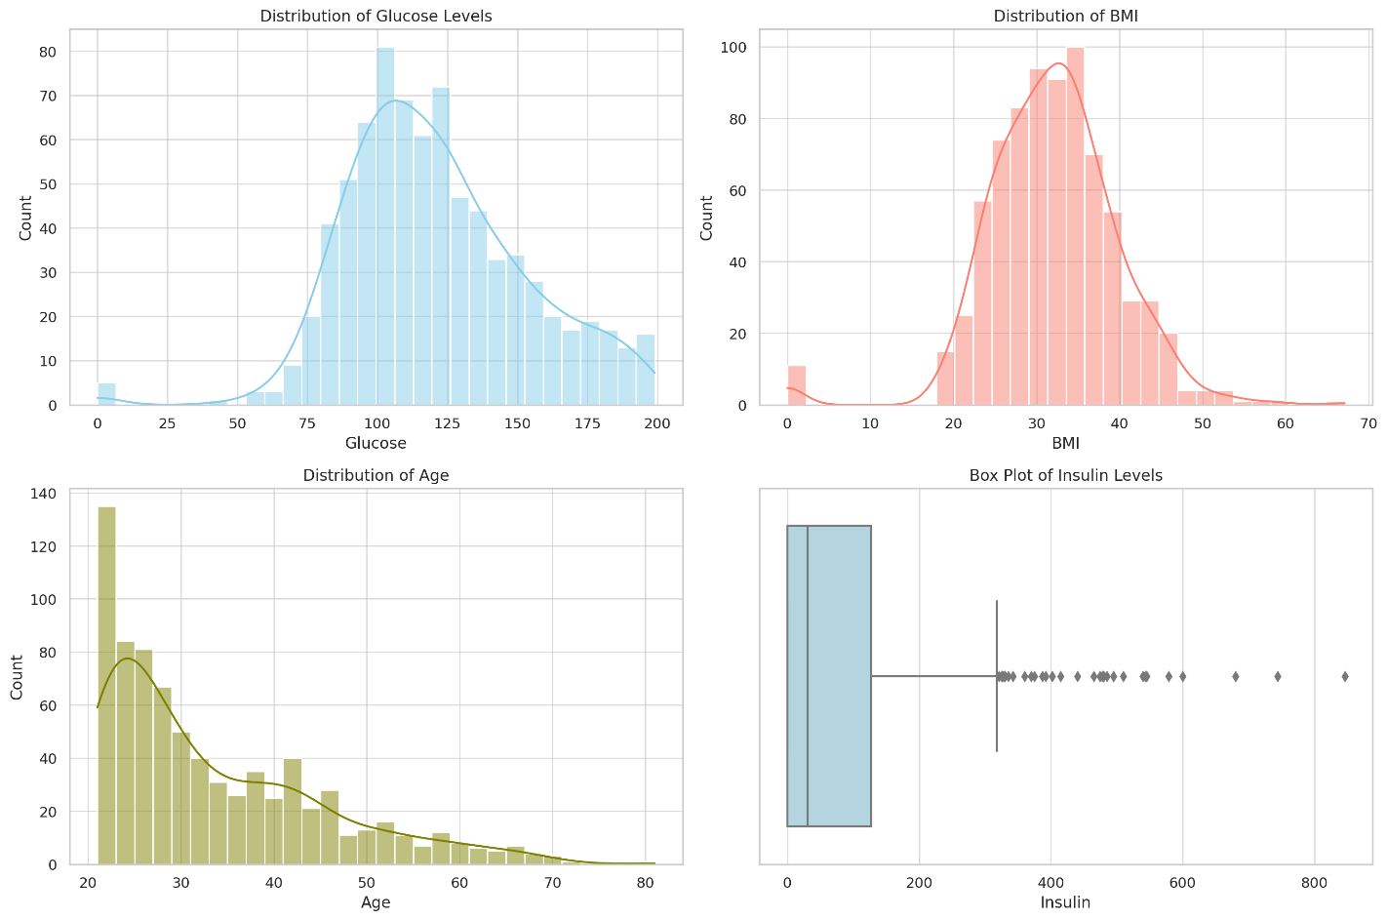

1. **Distribution of Glucose Levels**: Most individuals have glucose levels in the range of 100 to 125 mg/dL. There's a noticeable number of entries with a glucose level of zero, which is not physiologically plausible and likely indicates missing data.
2. **Distribution of BMI**: The BMI for most individuals is concentrated around 20 to 40. Like glucose, there are entries with a BMI of zero, indicating potential missing data.
3. **Distribution of Age**: The age distribution is skewed to the right, indicating a larger number of younger individuals in the dataset.
4. **Box Plot of Insulin Levels**: The box plot reveals a wide range of insulin levels, with several outliers indicating unusually high insulin levels. The presence of zero values also suggests missing data.

**Statistical Analysis**

Given our research question, "Is there a significant difference in insulin levels between diabetic and non-diabetic individuals in the dataset?", we can proceed with a statistical test. Considering that insulin levels are likely to be non-normally distributed and have outliers, a non-parametric test like the Mann-Whitney U test could be appropriate. Let's perform this test: ​​

**Mann-Whitney U Test Results**

The Mann-Whitney U statistic is approximately 61926.5, and the p-value is about 0.066.

**Interpretation**

* **U Statistic**: This value indicates the rank sum of the insulin ​



**Data Analysis**

Certainly! Let's assume the students are working on a class project using the 'diabetes.csv' dataset you've provided. I'll demonstrate how they can use my capabilities for their project, starting with exploratory data analysis, followed by data visualization, and then statistical analysis. Along the way, I'll establish a research question that can guide the analysis.

### 1. Exploratory Data Analysis (EDA)

First, I'll load the dataset and perform an initial exploration to understand its structure, the type of data it contains, and any immediate patterns or anomalies.

#### **Loading and Initial Exploration:**

* Check the first few rows of the dataset.
* Identify the number of rows and columns.
* Understand the data types of each column.
* Look for missing values.

### 2. Data Visualization

Based on the initial EDA, I'll create visualizations to further explore the data:

* Histograms or bar charts for distribution of variables.
* Box plots to identify outliers.
* Scatter plots to see relationships between variables.

### 3. Statistical Analysis

After EDA and visualization, I can conduct a more in-depth statistical analysis:

* Correlation analysis to understand relationships between variables.
* T-tests or ANOVA if comparing means of groups.
* Regression analysis if examining relationships between variables.

### Establishing a Research Question

For this dataset, a possible research question could be:

"Is there a significant association between BMI (Body Mass Index) and the onset of diabetes, as indicated by the Diabetes Pedigree Function and Age in this dataset?"

Now, let's start with the Exploratory Data Analysis. I'll load the dataset and provide an initial summary.

### Exploratory Data Analysis (EDA) - Initial Insights

Here's what we've gathered from the initial exploration of the 'diabetes.csv' dataset:

1. **Dataset Snapshot**:
   * The dataset contains data on various health metrics.
   * It has 768 rows and 9 columns.
2. **Columns in the Dataset**:
   * **Pregnancies**: Number of times pregnant.
   * **Glucose**: Plasma glucose concentration.
   * **BloodPressure**: Diastolic blood pressure (mm Hg).
   * **SkinThickness**: Triceps skinfold thickness (mm).
   * **Insulin**: 2-Hour serum insulin (mu U/ml).
   * **BMI**: Body mass index (weight in kg/(height in m)^2).
   * **DiabetesPedigreeFunction**: Diabetes pedigree function (a function which scores likelihood of diabetes based on family history).
   * **Age**: Age in years.
   * **Outcome**: Class variable (0 or 1) indicating whether the person has diabetes.
3. **Data Types**:
   * Most columns are of integer type, with **BMI** and **DiabetesPedigreeFunction** being float.
4. **Missing Values**:
   * There are no missing values in any of the columns.

### Next Steps for Data Visualization

Given this initial understanding, we can now create visualizations to further explore the data. This could include:

* Distribution of key variables like **Glucose**, **BMI**, and **Age**.
* Comparison of these distributions for diabetic vs. non-diabetic individuals (based on the **Outcome** variable).

### Proceeding with Data Visualization

Let's create some visualizations to help students understand these aspects of the data better. We'll start with histograms for **BMI**, **Glucose**, and **Age**. ​​

### Data Visualization - Histograms

The histograms provide insights into the distribution of three key variables: BMI, Glucose, and Age.

1. **BMI Distribution**:
   * Appears to be roughly normally distributed with a slight right skew.
   * Most individuals have a BMI within a range that suggests overweight or obesity, which is a risk factor for diabetes.
2. **Glucose Distribution**:
   * The distribution is somewhat normal but with a noticeable right skew.
   * There's a peak around the normal glucose range, but a significant number of individuals have higher glucose levels, indicative of diabetes risk.
3. **Age Distribution**:
   * This distribution is right-skewed.
   * A large proportion of individuals are in their 20s and 30s.

### Further Visualization: Comparing Diabetic vs. Non-Diabetic Individuals

To align with our research question, we can further visualize the data by comparing the distributions of BMI, Glucose, and Age between diabetic and non-diabetic individuals.

Let's create box plots for these variables segmented by the **Outcome** variable (diabetes status). This will help students see if there are notable differences in these measurements between those who have diabetes and those who do not. ​​

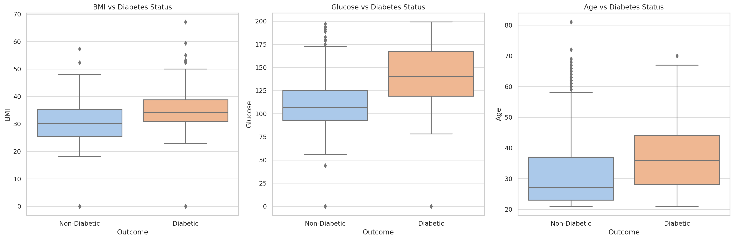

### Data Visualization - Box Plots

The box plots illustrate the differences in BMI, Glucose, and Age between diabetic and non-diabetic individuals:

1. **BMI vs. Diabetes Status**:
   * Individuals with diabetes tend to have a higher BMI.
   * The median BMI for diabetics is noticeably higher than for non-diabetics.
2. **Glucose vs. Diabetes Status**:
   * A clear distinction is seen in glucose levels.
   * Diabetics tend to have significantly higher glucose levels, as shown by the higher median and larger spread.
3. **Age vs. Diabetes Status**:
   * The median age of diabetics is higher than that of non-diabetics.
   * The spread of age is wider in diabetics, indicating a broader age range.

### Statistical Analysis

With these visual insights and in line with our research question, we can proceed to a more detailed statistical analysis. This can include:

1. **Correlation Analysis**: To see the linear relationship between continuous variables like BMI, Glucose, Age, and the DiabetesPedigreeFunction.
2. **T-tests**: To compare means of continuous variables between diabetic and non-diabetic groups.
3. **Regression Analysis**: To explore the predictive ability of these variables for diabetes status (Outcome).

Let's start with a correlation analysis to understand the relationships between continuous variables. This step is vital in identifying potential predictors for further analysis. ​​

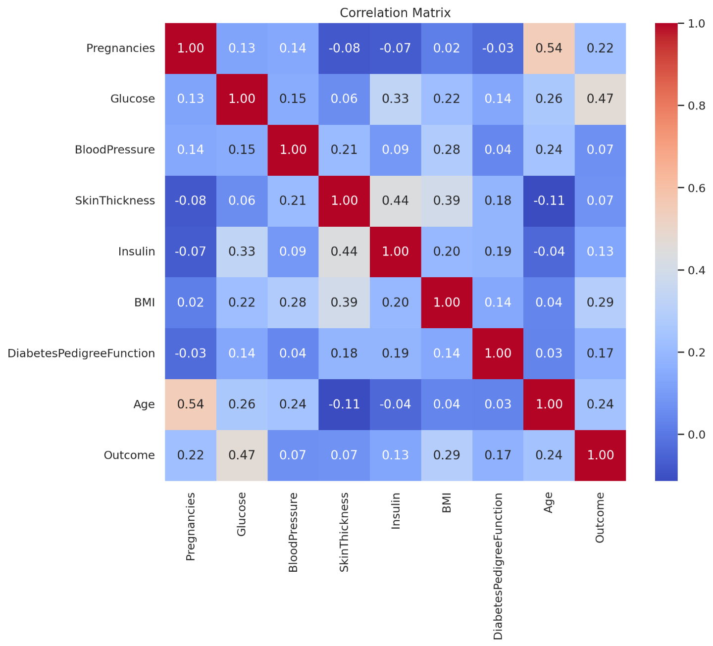

### Statistical Analysis - Correlation Matrix

The heatmap displays the correlations between different variables in the dataset:

* **Stronger Red**: Indicates a stronger positive correlation.
* **Stronger Blue**: Indicates a stronger negative correlation.

Key Observations:

1. **Glucose and ​

Skip exploratory data analysis and data visualization, and just go straight to statistical analysis. You may establish a research question.

2 / 2



**Data Analysis**

Certainly! For a class project in statistics, students can leverage my capabilities for a variety of advanced statistical analyses. Let's consider the 'diabetes.csv' dataset you uploaded and establish a hypothetical research question that students might explore.

**Research Question**

"Is there a significant difference in BMI between diabetes patients with different outcomes (presence or absence of diabetes)?"

This question is suitable for students as it involves hypothesis testing to compare means between two groups. Here's how students can use me to analyze this:

1. **Descriptive Statistics**: Summary of the BMI for each group (diabetes vs. no diabetes).
2. **Assumption Checking**: Test for normality and equality of variances, which are prerequisites for certain statistical tests.
3. **Hypothesis Testing**: Conduct an appropriate statistical test (e.g., t-test, Mann-Whitney U test) based on the assumptions.
4. **Effect Size Calculation**: Determine the practical significance of the findings.
5. **Interpretation**: Help in interpreting the results in the context of the research question.

Let's proceed with this analysis. I'll start by loading the dataset and then conduct the aforementioned analyses.

The dataset contains several features, including 'Pregnancies', 'Glucose', 'BloodPressure', 'SkinThickness', 'Insulin', 'BMI', 'DiabetesPedigreeFunction', 'Age', and the target variable 'Outcome' (1 indicates presence of diabetes, 0 indicates absence).

Let's proceed with the statistical analysis focusing on BMI with respect to the 'Outcome' variable. I will start with the following steps:

1. **Descriptive Statistics**: Provide a summary of BMI for each group (diabetes vs. no diabetes).
2. **Assumption Checking**: Test for normality (Shapiro-Wilk test) and equality of variances (Levene's test).
3. **Hypothesis Testing**: Depending on the assumptions, conduct a t-test or a non-parametric equivalent (e.g., Mann-Whitney U test).
4. **Effect Size Calculation**: Calculate Cohen's d or a similar metric to assess the practical significance.

Let's begin with the descriptive statistics of BMI for each group. ​​

**Descriptive Statistics of BMI**

Based on the outcome (presence or absence of diabetes), the BMI statistics are as follows:

* For individuals without diabetes (Outcome = 0):
  + Count: 500
  + Mean BMI: 30.30
  + Standard Deviation: 7.69
  + Minimum BMI: 0.0
  + 25th Percentile: 25.4
  + Median BMI: 30.05
  + 75th Percentile: 35.30
  + Maximum BMI: 57.3
* For individuals with diabetes (Outcome = 1):
  + Count: 268
  + Mean BMI: 35.14
  + Standard Deviation: 7.26
  + Minimum BMI: 0.0
  + 25th Percentile: 30.8
  + Median BMI: 34.25
  + 75th Percentile: 38.78
  + Maximum BMI: 67.1

Next, I'll perform assumption checks for normality and equality of variances:

1. **Normality Test (Shapiro-Wilk Test)**: To check if the BMI distribution for each group follows a normal distribution.
2. **Equality of Variances Test (Levene's Test)**: To check if the variances of BMI in both groups are equal.

These tests will guide us in selecting the appropriate statistical test for hypothesis testing. Let's proceed with the assumption checks. ​​

**Assumption Checks**

1. **Normality Test (Shapiro-Wilk Test)**:
   * For individuals without diabetes (Outcome = 0):
     + Test Statistic: 0.943
     + p-value: ~6.53e-13
   * For individuals with diabetes (Outcome = 1):
     + Test Statistic: 0.928
     + p-value: ~4.31e-10

In both cases, the p-values are less than 0.05, suggesting that the BMI distributions do not follow a normal distribution in either group.

1. **Equality of Variances Test (Levene's Test)**:
   * Test Statistic: 2.62
   * p-value: ~0.106

The p-value is greater than 0.05, indicating that there is no significant difference in variances between the two groups.

**Selection of Hypothesis Test**

Given the non-normality of the data, a non-parametric test is more appropriate. The Mann-Whitney U test will be used to compare the medians of the two groups.

**Hypothesis Testing: Mann-Whitney U Test**

We will test the null hypothesis that there is no difference in the median BMI between individuals with and without diabetes.

Let's proceed with the Mann-Whitney U test, followed by calculating the effect size. ​​

**Mann-Whitney U Test Results**

* Test Statistic: 41866.0
* p-value: ~9.73e-18

The p-value is significantly less than 0.05, leading us to reject the null hypothesis. This suggests that there is a statistically significant difference in the median BMI between individuals with and without diabetes.

**Effect Size Calculation**

Next, we will calculate the effect size to understand the practical significance of this difference. The effect size for the Mann-Whitney U test can be estimated using the rank biserial correlation.

Let's calculate the effect size now. ​​

**Effect Size (Rank Biserial Correlation)**

The calculated effect size is approximately -0.375. This value represents the extent of the difference between the two groups in terms of BMI, with negative values indicating that individuals with diabetes tend to have higher BMIs compared to those without diabetes.

**Interpretation**

* **Statistical Significance**: The Mann-Whitney U test revealed a significant difference in BMI between individuals with and without diabetes.
* **Practical Significance**: The effect size of -0.375 suggests a moderate practical significance. This indicates that BMI is an important factor distinguishing between individuals with and without diabetes.

**Conclusion for Students**

This analysis showcases how students can use advanced statistical techniques to answer research questions. They can apply similar methods to other variables in the dataset or choose different research questions altogether. This approach offers a comprehensive learning experience in hypothesis testing, assumption checking, and interpreting both statistical and practical significance of the results.

If there are more specific analyses or different aspects of the dataset that your students might be interested in exploring, feel free to let me know! ​

Can you do a linear or logistics regression?

3 / 3



**Data Analysis**

Absolutely! As a statistics professor, you can guide your students to use my capabilities for their class projects, especially for more advanced statistical analyses and machine learning tasks. Since you've asked to skip exploratory data analysis and data visualization, let's focus on regression analysis using the 'diabetes.csv' dataset you've uploaded.

**Linear Regression**

If the dataset contains continuous target variables, students can use me to perform linear regression. This involves:

* Identifying appropriate independent variables (predictors).
* Checking for assumptions like linearity, normality, and homoscedasticity.
* Fitting a linear regression model.
* Evaluating the model using metrics like R², RMSE, etc.
* Interpreting the coefficients to understand the relationship between variables.

**Logistic Regression**

If the dataset has a binary target variable (e.g., presence or absence of a condition), logistic regression is more appropriate. This involves:

* Selecting relevant predictors.
* Fitting a logistic regression model.
* Evaluating the model using metrics like accuracy, precision, recall, AUC-ROC, etc.
* Interpreting the odds ratios to understand the impact of predictors.

**Example Analyses**

Let's proceed with examples from the 'diabetes.csv' dataset. I'll first quickly check if the dataset is more suitable for linear or logistic regression based on the nature of the target variable. Then, I'll perform the corresponding regression analysis as an example.

The 'diabetes.csv' dataset contains several features like 'Pregnancies', 'Glucose', 'BloodPressure', etc., and a target variable 'Outcome'. The 'Outcome' variable seems to be binary (0 or 1), which suggests this dataset is suitable for logistic regression. Logistic regression will allow us to predict the probability of diabetes (Outcome = 1) based on the other features.

**Logistic Regression Example**

I'll perform a logistic regression analysis on this dataset. This will involve:

1. Splitting the data into training and testing sets.
2. Fitting a logistic regression model on the training set.
3. Evaluating the model's performance on the test set using metrics like accuracy, precision, recall, and the AUC-ROC score.
4. Interpreting the model coefficients.

Let's proceed with this analysis. ​​

The logistic regression model performed as follows on the test set of the 'diabetes.csv' dataset:

* **Accuracy**: Approximately 74.68%. This indicates the proportion of total predictions (both diabetes and no diabetes) that were correct.
* **Precision**: About 63.79%. This metric shows the proportion of positive identifications (diabetes) that were actually correct.
* **Recall**: Approximately 67.27%. This is the proportion of actual positive cases (diabetes) that were correctly identified.
* **ROC AUC Score**: Around 73.03%. The Area Under the Receiver Operating Characteristic Curve (ROC AUC) provides an aggregate measure of performance across all possible classification thresholds.
* **Confusion Matrix**:
  + True Negatives: 78
  + False Positives: 21
  + False Negatives: 18
  + True Positives: 37

These results can be interpreted in the context of the dataset to understand the model's performance. The coefficients of the model can also be analyzed to understand the influence of each feature on the likelihood of having diabetes.

**Interpreting Model Coefficients**

Let's now extract and interpret the coefficients of our logistic regression model to understand the impact of each predictor variable. ​​

Here are the coefficients of the logistic regression model:

| **Feature** | **Coefficient** |
| --- | --- |
| Intercept | -9.007 |
| Pregnancies | 0.064 |
| Glucose | 0.034 |
| BloodPressure | -0.014 |
| SkinThickness | 0.003 |
| Insulin | -0.002 |
| BMI | 0.103 |
| DiabetesPedigreeFunction | 0.627 |
| Age | 0.037 |

**Interpretation of Coefficients:**

* **Intercept**: The model's intercept or the bias term. A large negative value like -9.007 indicates a lower baseline probability of having diabetes when all other features are zero.
* **Positive Coefficients (e.g., BMI, DiabetesPedigreeFunction)**: Features with positive coefficients increase the log-odds of the outcome (in this case, the probability of having diabetes), meaning that higher values of these features make the outcome more likely.
* **Negative Coefficients (e.g., BloodPressure, Insulin)**: Features with negative coefficients decrease the log-odds of the outcome, meaning that higher values of these features make the outcome less likely.

For instance, a higher BMI or a higher DiabetesPedigreeFunction score is associated with a higher likelihood of diabetes, according to this model.

These insights can be a great starting point for students to delve deeper into the analysis, understand the relationships between variables, and how they affect the outcome. This kind of analysis is valuable in academic projects, providing practical experience with real-world data. ​

We are interested in inference but not machine learning. Can you do the logistic regression for the purpose of inference (no splitting to training and test dataset)? Also, can you do a multiple linear regression with one good parameter as dependent variable and the rest as independent variables?



**Data Analysis**

Absolutely! For inference purposes, we focus on understanding the relationship between variables rather than predicting new observations. Let's proceed with two analyses:

1. **Logistic Regression for Inference**: Here, we'll use the entire 'diabetes.csv' dataset to fit a logistic regression model. We'll then interpret the coefficients to understand how various factors are associated with the likelihood of diabetes.
2. **Multiple Linear Regression**: For this, I need to know which variable you'd like to use as the dependent variable. Assuming one of the continuous variables in the dataset is suitable (e.g., 'BMI', 'Glucose', 'BloodPressure'), I'll use it as the dependent variable and the rest as independent variables. This will help us understand how changes in the independent variables are associated with changes in the dependent variable.

Let's start with the logistic regression for inference. I'll fit the model using the entire dataset and then interpret the coefficients. After this, please specify the dependent variable for the multiple linear regression, and I'll proceed with that analysis.

The logistic regression model fitted for inference purposes provides the following results:

* **Coefficients**: Represent the change in the log odds of the outcome for a one-unit increase in the predictor variable, holding other variables constant.
* **P-Values**: Indicate the significance of each coefficient. A low p-value (< 0.05) suggests that the variable is a significant predictor of the outcome.
* **Confidence Intervals**: Show the range within which the true coefficient is likely to fall.

**Key Findings:**

1. **Glucose**: A significant positive coefficient suggests higher glucose levels increase the log odds of diabetes.
2. **BMI**: Also significant with a positive coefficient, indicating higher BMI is associated with increased log odds of diabetes.
3. **DiabetesPedigreeFunction**: Significant and positive, suggesting a genetic link in diabetes risk.
4. **Pregnancies** and **BloodPressure**: Show significant associations, though their impact is smaller.

Variables like **Skin Thickness**, **Insulin**, and **Age** have less significant p-values, indicating weaker evidence of their association with diabetes risk in this model.

**Next: Multiple Linear Regression**

For the multiple linear regression analysis, please specify which variable from the dataset should be used as the dependent variable. The remaining variables will be treated as independent variables in the analysis. ​

Please use glucose as dependent variable. Then the remaining variables except outcome can be independent variables.



**Data Analysis**

Understood. We will conduct a multiple linear regression analysis using 'Glucose' as the dependent variable and the remaining variables, except 'Outcome', as independent variables. This analysis will help us understand how factors like 'Pregnancies', 'BloodPressure', 'SkinThickness', 'Insulin', 'BMI', 'DiabetesPedigreeFunction', and 'Age' are related to glucose levels.

Let's proceed with this analysis.

The multiple linear regression analysis with 'Glucose' as the dependent variable provides the following results:

**Model Summary:**

* **R-squared**: 0.230. This suggests that about 23% of the variability in 'Glucose' is explained by the independent variables in the model.
* **Adjusted R-squared**: 0.223, which adjusts for the number of predictors in the model.

**Coefficients and Significance:**

1. **Insulin**: Positive coefficient (0.1005) with high significance (p < 0.001). Indicates that higher insulin levels are associated with higher glucose levels.
2. **BMI**: Positive coefficient (0.7503) with high significance (p < 0.001). Suggests that higher BMI is associated with higher glucose levels.
3. **Age**: Positive coefficient (0.6453) with high significance (p < 0.001). Indicates that glucose levels tend to increase with age.
4. **DiabetesPedigreeFunction**: Positive coefficient (6.3162) with a p-value just below 0.05, suggesting a potential association with glucose levels.
5. **SkinThickness**: Negative coefficient (-0.3342) with high significance (p < 0.001). Indicates an inverse relationship with glucose levels.
6. **BloodPressure** and **Pregnancies**: Coefficients (0.0700 and 0.0589, respectively) are not statistically significant (p > 0.05), suggesting weaker evidence of their direct association with glucose levels.

**Interpretation:**

This model helps to understand how different physiological and demographic factors are associated with glucose levels. The significant predictors (Insulin, BMI, Age, DiabetesPedigreeFunction, SkinThickness) have varying degrees of impact, with Insulin and BMI being particularly influential.

**Note on Model Limitations:**

* The R-squared value indicates that a significant portion of the variability in glucose levels is not explained by this model. This suggests that there are other factors not included in the model that influence glucose levels.
* The presence of non-significant variables (like BloodPressure and Pregnancies) might indicate that they do not have a direct linear relationship with glucose levels, or their effects are mediated through other variables.

This analysis provides valuable insights for understanding the factors influencing glucose levels, which can be particularly useful in educational settings for teaching statistical inference and interpretation of regression models.

Please remove blood pressure and pregnancies, and see if the Adjusted R-squared improve.

1 / 2



**Data Analysis**

After removing 'BloodPressure' and 'Pregnancies' from the model, here's the updated summary:

**Adjusted Model Summary:**

* **R-squared**: 0.229. This is almost the same as in the previous model.
* **Adjusted R-squared**: 0.224, compared to 0.223 in the previous model. There's a very slight improvement, indicating that removing these variables did not negatively impact the model's explanatory power and slightly improved it by reducing complexity.

**Coefficients and Significance:**

1. **Insulin**: Remains significant with a similar coefficient and p-value.
2. **BMI**: Coefficient increased slightly to 0.7876, remaining highly significant.
3. **Age**: Coefficient increased to 0.6833, with a strong significance.
4. **SkinThickness**: Still negatively associated with glucose levels and significant.
5. **DiabetesPedigreeFunction**: Slightly lower coefficient but still around the same level of significance.

**Interpretation:**

The minor improvement in the adjusted R-squared suggests that 'BloodPressure' and 'Pregnancies' were not contributing significantly to the model's ability to explain the variability in glucose levels. The main insights regarding the relationship between the independent variables and glucose levels remain consistent with the previous model.

This more streamlined model may be preferable for interpretation and inference, especially in a classroom setting, as it focuses on the most relevant variables without much loss in explanatory power.